EU Industry Days 2021  
Website review

Contacts:   
Yves Moulin – Senior Project Manager  
Lara Jabour – Junior Project Manager - SCIC CMO

15/09/2021

# TABLE OF CONTENT

TABLE OF CONTENT 2

Revision of the document 3

1. Introduction 4

2. Purpose 4

3. Project architecture 5

4. Framework 5

5. Server requirements 6

6. Database structure 6

7. Third-party services 7

7.1 Swapcard 7

7.2 Mapbox 8

7.3 Acast 8

7.4 SparkPost 8

7.5 Twitter 9

8. Appendix 9

# Revision of the document

|  |  |  |  |
| --- | --- | --- | --- |
| Version | Author | Date | Comments |
| V1 | Hubert Canart | 15/09/2021 | Initial version |
|  |  |  |  |
|  |  |  |  |
|  |  |  |  |
|  |  |  |  |
|  |  |  |  |

# Introduction

The website [www.euindustrydays.eu](http://www.euindustrydays.eu) has served as the central point of communication about the 2021 edition of the EU Industry Days, which took place from 23 to 26 February 2021. It contains the basic information related to the event (program, sessions, speakers, local events) and the registration/authentication features that grant access to the virtual event.

The hosting of the website on the contractor's servers has now expired.

# Purpose

This document aims to give a brief overview of the web application and the prerequisites necessary for its possible reinstallation inside the European Commission's environment.

It tackles several topics:

* Project architecture;
* Framework;
* Server requirements;
* Database structure;
* Third-party services.

This document lists the APIs and protocols used by the third-party services to ensure the transfer of data as well as the authentication models. It does not explain how they work.

# Project architecture

The website is the center of an environment that includes different services.

The end user accesses the front-end website. He registers there. Once authenticated, he accesses Swapcard with Single Sign On (SSO) from his private area.

The administrator has privileges to access the back-end website. He manages the content and the users.

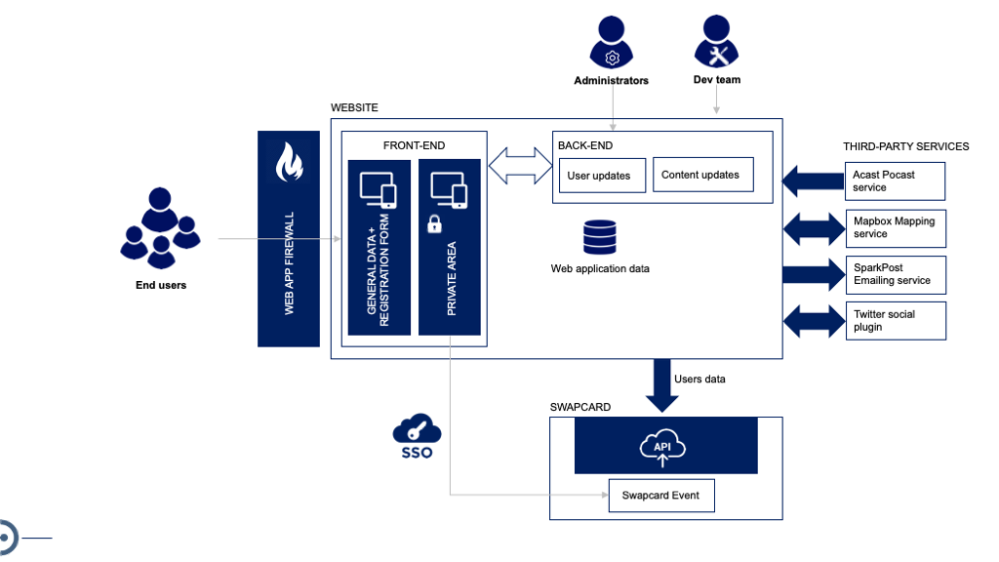

*Figure 1: Picture of the project environments*

# Framework

The website is built on a technological suite composed of the Laravel[1] development framework. Laravel is a free, open-source PHP web framework intended for the development of web applications following the model–view–controller (MVC) architectural pattern and based on Symfony. The project has been developed in Laravel version 8[2].

Bootstrap and the components of the EC component-library[3] are used for the front-end layer.

# Server requirements

The Laravel framework has a few system requirements. Please ensure that the web server hosting the web application has the following minimum PHP version and extensions:

* PHP >= 7.3
* BCMath PHP Extension
* Ctype PHP Extension
* Fileinfo PHP Extension
* JSON PHP Extension
* Mbstring PHP Extension
* OpenSSL PHP Extension
* PDO PHP Extension
* Tokenizer PHP Extension
* XML PHP Extension

# Database structure

For the needs of the project Laravel 8 interacts with a MySQL[4] database.

The database includes the following tables[5]:

* activities;
* activity_user;
* countries;
* crons;
* failed_jobs;
* files;
* interest_user;
* interests;
* languages;
* learn_about_euid_user;
* learn_about_euids;
* local_events;
* logs;
* media;
* migration;
* moderator_session;
* moderators;
* organization_types;
* pages;
* password_resets;
* pdf_programmes;
* role_user;
* roles;
* session_speaker;
* sessions;
* speakers;
* users;
* zzz_cblue_last_backups.

# Third-party services

The web application interacts with third-party services.

## 7.1 Swapcard

Swapcard is an online service that allows the organization of fully virtual events and conferences. For the needs of the project the web application and Swapcard were linked to reach two objectives:

1. Data transfer

User profiles data and roles are transferred from the web application to Swapcard via the Swapcard API[6].

An API key is necessary to authorize the website using the Swapcard service.

1. User authentication (SSO)

The user authentication allows the user to log in on the Swapcard event with the web application authentication. SAML 2.0 is used to ensure Single Sign On[7].

SAML 2.0 is an XML-based protocol that uses security tokens containing assertions to pass information about a user between a SAML authority, named an Identity Provider (IdP), and a SAML consumer, named a Service Provider (SP). In the context of the project, the web application acts as IdP and Swapcard acts as SP.

## 7.2 Mapbox

Mapbox[8] is a provider of custom online maps for websites and applications.

In the context of the project, the Mapbox service has been used to deliver the local events map. Styling customization[9] has been done via the *Mapbox Studio* account.

An API key is used to synchronize the map styling and the map hosted on the website.

## 7.3 Acast

Acast is an online provider that provides hosting, monetization and growth support to podcasts.

In the context of the project, podcasts hosted on Acast were embedded on a website page using iframes.

## 7.4 SparkPost

SparkPost[10] is an emailing service that sends electronic messages to the customer.

In the context of the project, SparkPost has been used to deliver transactional messages like account creation, reminder password, event confirmation, role modification as well as contact form submissions.

An API key is necessary to authorize the website using the SparkPost service.

## 7.5 Twitter

Twitter is a social media service on which users post and interact with messages known as "tweets".

In the context of the project, a Twitter social plugin has been used to display the messages #euindustrydays on Twitter.

Displaying the messages in the social plugin requires Twitter_Consumer_Key, Twitter_Consumer_Secret, Twitter_Access_Token and Twitter_Access_Token_Secret.

# Appendix

The following resources are delivered with the document:

* Website source code[11]
* MySQL database scheme
* MySQL database
* Mapbox css

1. <https://laravel.com/>
2. An export of the web application source code is available in the appendix.
3. <https://ec.europa.eu/component-library/ec/>
4. MySQL 5.7+ is required.
5. Complete database scheme is available in the appendix.
6. <https://developer.swapcard.com/api/graphql-event-api>
7. <https://developer.swapcard.com/api/single-sign-on>
8. <https://www.mapbox.com/>
9. An export of the Mapbox css file is available in the appendix.
10. <https://www.sparkpost.com/>
11. All secret API keys and passwords have been removed from the source code.